**ENABLING KMEMLEAK TO ANALYZE MEMORY LEAK**

**INTRO:**

The following procedure explains how to enable kmemleak in OpenWRT/QSDK. This helps us to understand which process/kernel modules leaks memory. Kmemleak provides a way of detecting possible kernel memory leaks in a way similar to a tracing garbage collector.

**PROCDURE:**

1. In qsdk directory do “make menuconfig”
2. Navigate to “Global build settings”

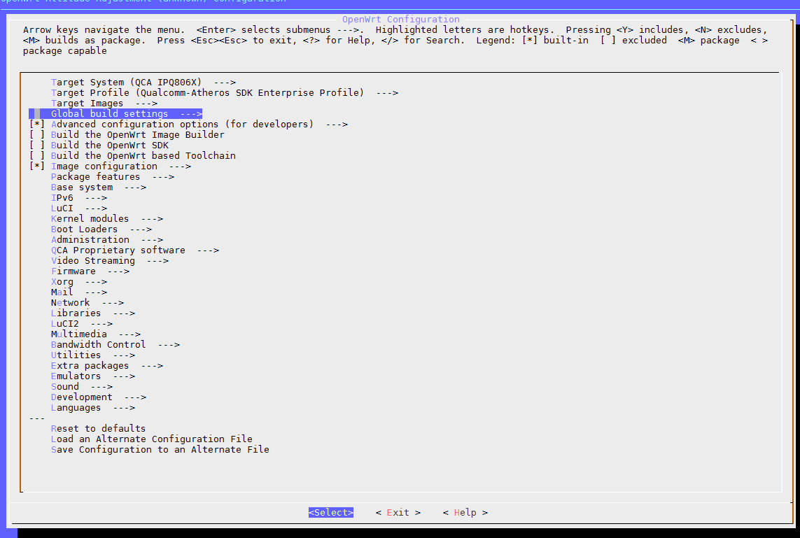

1. Select the below two option by pressing “y”

* Compile the kernel with memory leak detector
* Enable /proc slab debug info

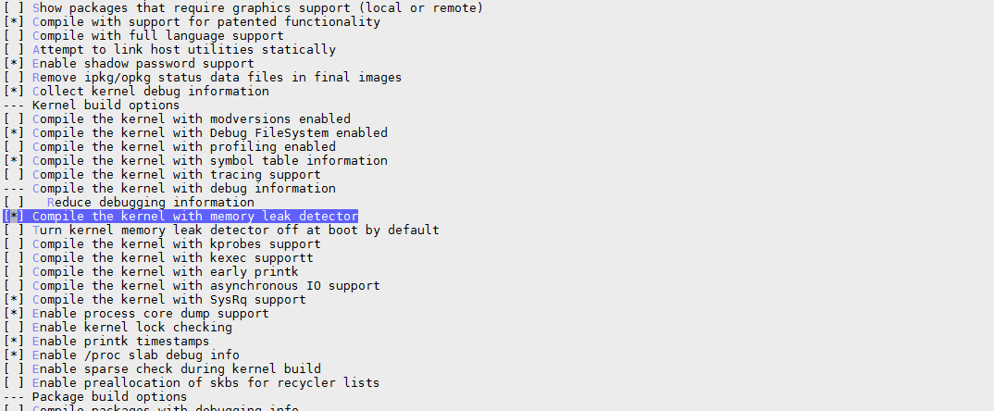

1. Exit the menu and give “yes” when it asks if you want to save the config.
2. Find and open file named “kmemleak.c” in your build system (usual path is ./qsdk/qca/src/linux/mm/kmemleak.c).
3. Replace all occurrence of “EXPORT_SYMBOL_GPL(kmemleak_alloc);” string with “EXPORT_SYMBOL(kmemleak_alloc);”
4. Save the file and make the build, after build is done flash the image in AP.
5. You will see prints like

kmemleak: 4 new suspected memory leaks (see /sys/kernel/debug/kmemleak” in dmesg

You can see the full list of leaks when you cat /sys/kernel/debug/kmemleak file.

**Furthur reading:**

Learn more about leaks from below Linux documentation

https://www.kernel.org/doc/Documentation/kmemleak.txt